2021 Indiana State Fair 4-H Education Stations

Purpose
The Indiana State Fair provides a venue for about 850,000 people to learn about youth and agriculture. In particular, the approximately 10,000 exhibits displayed by 4-H members in the 4-H Exhibit Hall, Centennial Hall, and Agriculture & Horticulture Building not only helps visitors learn about the state fair’s mission, but also helps promote the educational opportunities available to youth through the Indiana 4-H program. One way to not only promote 4-H but also educate the public about youth and agriculture is to provide an opportunity for 4-H Clubs to conduct hands-on learning activities related to a 4-H project with guests in a make-it and take-it style education station.

Who can apply
Any 4-H Club that has officially been chartered by Purdue Extension and is in good standings with their County Extension Office may submit an application.

Procedure
- The County 4-H Youth Development Extension Educator will promote this opportunity to the 4-H Clubs that are in good standings within their county.
- The 4-H Club adult volunteer leaders will work with and provide guidance to the club members to generate ideas for an education station. When the club determines the project they want their education station related to, the adult volunteers will provide guidance to the club members as they complete the application.
- All applications must be submitted to the County 4-H Youth Development Extension Educator no later than June 15, 2021.
- County 4-H Youth Development Extension Educators will review and approve submitted applications. County approved applications must be submitted to the State 4-H Office no later than June 20, 2021.
- The State 4-H Office will select 8-12 4-H Clubs from all applicants to provide a 4-H Education Station at the 2021 Indiana State Fair. Each 4-H Club approved will receive a $400.00 financial award.
- 4-H Clubs will be notified by June 30, 2021 whether or not their application was approved to be an Indiana State Fair 4-H Education Station. County 4-H Youth Development Extension Educators will work with 4-H Club volunteers to establish a financial record keeping system that is in compliance with the 4-H Financial Policies as outlined in the Indiana 4-H Policies and Procedures manual.
- 4-H Clubs approved to conduct a 4-H Education Station must submit their final report to their County 4-H Youth Development Extension Educator by September 1, 2021.
- The County 4-H Youth Development Extension Educator will forward the club’s final report to the State 4-H Office by September 15, 2021.
- The State 4-H Office will issue a check of $400.00 for the final award payable to the 4-H Clubs after receiving the club’s final report.

Responsibilities of the Indiana 4-H Youth Development Program Specialist
- Establish an application review committee to review submitted proposals and select applications for approval.
- Answer questions and provide support during the application process and to approved applicants.
- Schedule approved applicants based on dates available listed in the application.
- Provide space in the 4-H Exhibit Hall, Centennial Hall, or Agriculture Horticulture Building for the approved 4-H Education Station.
- Advertise and promote the 4-H Education Station and 4-H Club at the Indiana State Fair.
- Provide admission tickets to the Indiana State Fair. Complimentary parking passes are not available.
- Provide Indiana 4-H promotional materials for distribution to Indiana State Fair guests participating in the 4-H Education Station.
- Provide approved 4-H Clubs a $400 financial award to fund the supplies and expenses related to the Education Stations.

Responsibilities of the County 4-H Youth Development Extension Educator and 4-H Club Adult Volunteers
- Provide guidance and support to the 4-H members in generating ideas and completing the application.
- Establish the method for fiscal management that is in compliance with the 4-H Financial Policies as outlined in the Indiana 4-H Policies and Procedures manual.
- Assist 4-H members in practicing their 4-H Education Station in a public setting prior to their arrival at the Indiana State Fair (the local county fair might be a possibility).
- Provide 6-10 4-H members and 2-3 4-H adult volunteers to oversee the 4-H Education Station at the Indiana State Fair during the 4 hour assigned time period.
- Purchase the necessary supplies for 200-400 Indiana State Fair guests to participate in the 4-H Education Station using the financial award provided.
- Submit the application and reports by the specified deadlines.

Reporting Requirements
Following the Indiana State Fair a report is to be submitted to the State 4-H Office describing the experience of the 4-H members leading the 4-H Education Station. This report will include the number of Indiana State Fair guests participating in the 4-H Education Station, general observations and reactions of those guests, general observations and reactions of 4-H members leading the station, noteworthy anecdotal comments provided by guests, and photos of the 4-H Education Station activities.

Potential Education Stations
- Aerospace – aerodynamic principles with balsawood airplanes or paper airplanes
- Crafts – make it and take it crafts using recyclable materials
- Livestock – purpose of animal identification using ear tags or notches in felt ears
- Cake Decorating – piping icing using store purchased cookies and store purchased icing
- Garden – principles of planting seeds in individual pots to take home
- Photography – basic camera operations using the rule of thirds
- Dairy – the science of turning cream into butter
- Expressive Arts – vegetable art carving
- Other activities related to any of the projects offered through Indiana 4-H

SPECIAL NOTE FOR 2021 – Education station activities must be planned to accommodate social distancing. Any item shared between individuals (glue bottles, containers, etc.) are to be wiped clean after each use using a disinfecting wipe. All youth and adults working the education station are expected to comply with health department regulations in place at that time.

Indiana State Fair
4-H Education Station Application

Name of 4-H Club County

Name of 4-H Adult Volunteers Assigned to this 4-H Club

Contact Information for Primary 4-H Club Adult Volunteer:

Mailing Address Phone

4-H Education Station Title

4-H Project(s)

How many people from your 4-H Club will be involved at the Indiana State Fair?
4-H Members Adult Volunteers

(Use as much space as necessary to answer the following questions.)
What are the primary goals or objectives Indiana State Fair guests should learn from this proposed 4-H Education Station?

How will the 4-H members benefit from conducting this proposed 4-H Education Station in both a public setting used for practice prior to the Indiana State Fair and during the assigned time at the Indiana State Fair?

Describe what participants will experience and/or do at this 4-H Education Station.

Our 4-H Club wants to be considered for the following dates (check all dates your club is available):
August 7 August 8
August 14 August 15
August 21 August 22

Proposed Budget:
Item Description | Number | Cost
Total Proposed Budget Cost

We have reviewed this award application and submit it for consideration. If approved, we agree to follow the financial accounting practices as outlined in the Indiana 4-H Policies and Procedures manual.

Signature of 4-H Club President or Member

Signature of 4-H Adult Volunteer

Signature of County 4-H Youth Development Extension Educator

Submit application, budget, and substitute W-9 form to county 4-H Youth Development Educator by June 15, 2021.

County educator to submit by June 20, 2021 to: Tony Carrell, Extension Specialist
State 4-H Office
615 W. State Street
West Lafayette, IN 47907
tcarrell@purdue.edu

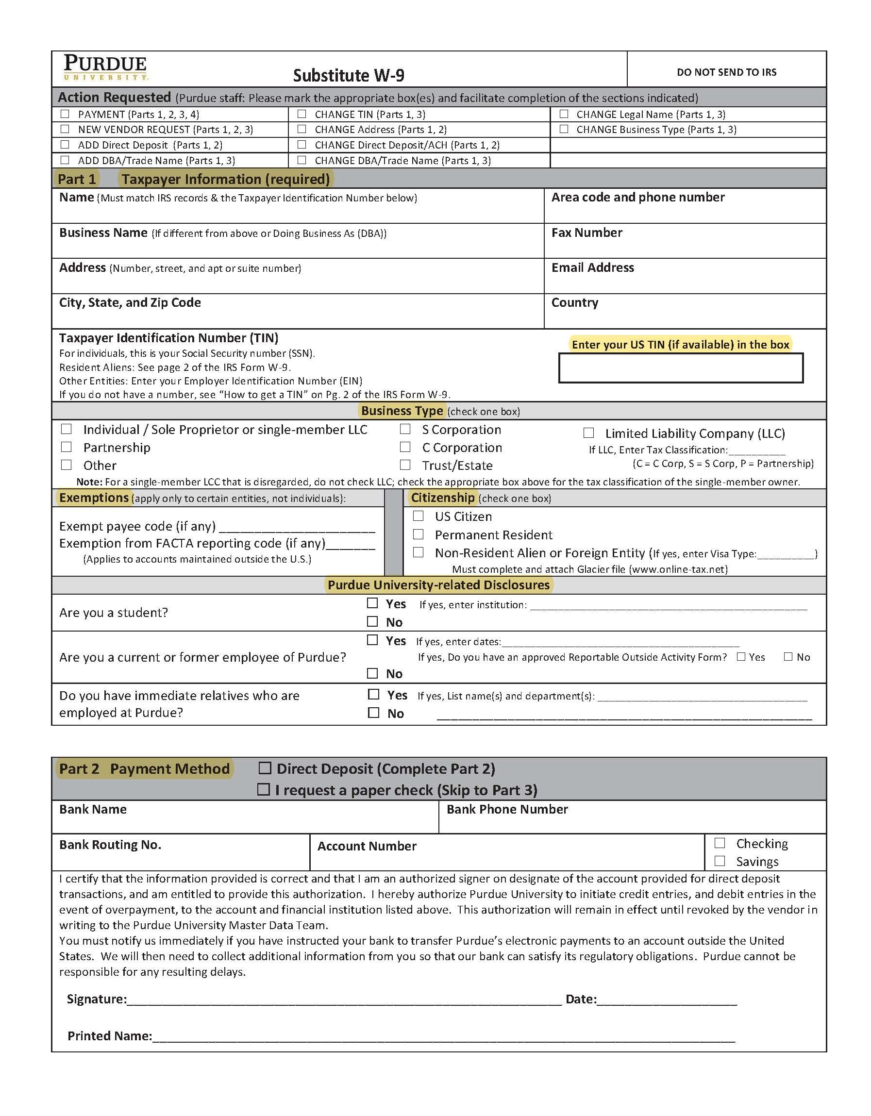
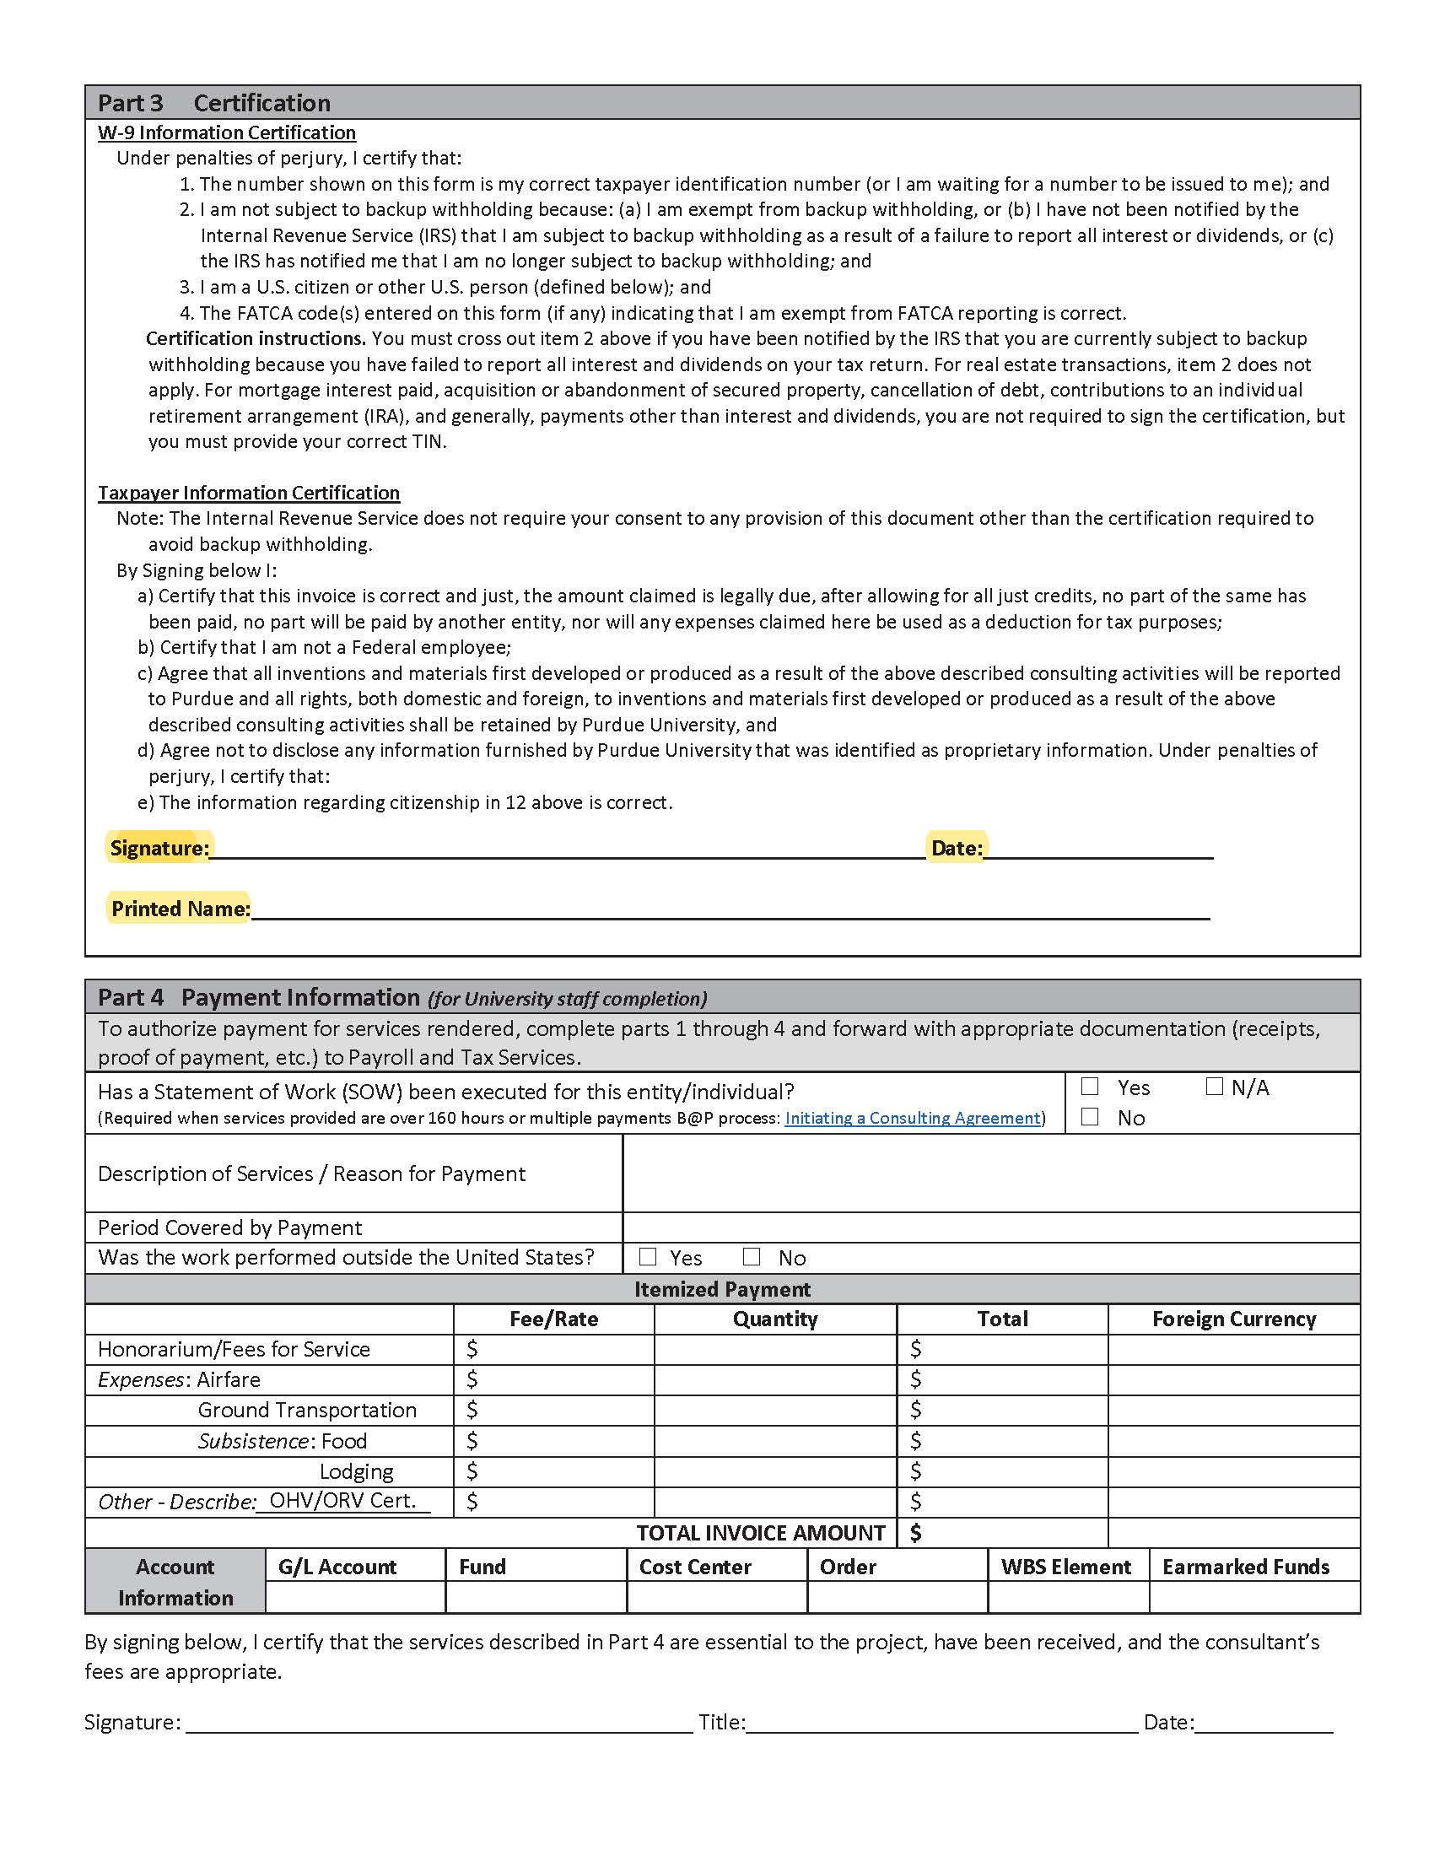
Indiana State Fair
4-H Education Station Report

Name of 4-H Club County

4-H Education Station Title

4-H Project(s)

How many people from your 4-H Club were involved at the Indiana State Fair?
4-H Members Adult Volunteers

How many Indiana State Fair guests participated in this 4-H Education Station?
Youth Adults

(Use as much space as necessary to answer the following questions.)
- What obstacles or challenges did the 4-H Club face when trying to meet the goals or objectives of this 4-H Education Station? How did you overcome these obstacles or challenges?

- If your 4-H Club were to do this again, what would you do differently?

- What other settings could your 4-H Club replicate this activity? Are you planning to do so?

- In summary, what did the 4-H members learn from planning and conducting this 4-H Education Station?

- Please list any noteworthy anecdotal comments of participants overheard by 4-H Club members or adult volunteers.

- Include in this report 4-6 photos of 4-H members interacting with participants at the 4-H Education Station.

We have reviewed this report and by signing we agree that the information is true and accurate.

Signature of 4-H Club President or Member

Signature of 4-H Adult Volunteer

Signature of County 4-H Youth Development Extension Educator

Submit by September 15, 2021 to: Tony Carrell, Extension Specialist
State 4-H Office
615 W. State Street
West Lafayette, IN 47907
tcarrell@purdue.edu

